Celebration with cake (online cake Purchase)
Design Document

Version 1.0



Group Id: S18023267F
Supervisor Name: ShafaqNasir

Revision History
Date (dd/mm/yyyy) | Version | Description | Author
06/07/2018 | 1.0 | ONLINE CAKE PURCHASE SYSTEM is a website designed primarily for use in the cake delivery industry. This system will allow hotels and restaurants to increase scope of business by reducing the labor cost involved. The system also allows to quickly and easily manage an online menu which customers can browse and use to place orders with just few clicks. And it makes possible for every customer to buy cake on his own requirement ,size and taste in by providing him different categories of it. | Mc160200945

Table of Contents

- Introduction of Design Document
- Entity Relationship Diagram (ERD)
- Sequence Diagrams
- Architecture Design Diagram
- Class Diagram
- Database Design
- Interface Design
- Test Cases

- Introduction of Design Document

The detailed study about operations that are performed by a system and the relationship between them within or our side of the system is called Analysis of a system of the given project.
Important Points Regarding System Analysis:
- Customer requirement are based upon the accomplishment to the requirement and the specification of new system.
The new and accurate system and the relationship with each other performed functions with specific functional hierarchy.
In the requirement analysis phase, different models are developed to convey requirement of the system. The Analysis phase is where the project lifecycle begins.
Objectives of Design Document:
The main object of this design is to analyze and understand the system in detail .In this way the features and constitute part of least feasible solution are identified and then documented. During the design phase, the focus shift from “What to how” i.e. we try to answer the question to how to build the system.
Benefits of this phase in a software development project:

The design activity provides us many benefits as it make us enable to ascertain and know that each and everything working activities in a concise way .It provides us the criteria as it enable us to know the whole process in a complete manner of it .It enables the user to organize IT requirement
for a business and make the blue print of the software that is built by the person to facilitate the business operations.

- Entity Relationship Diagram (ERD) (To be developed using Microsoft Visio or any other drawing software of your choice)
ID
Password
name
Client_Id

order
Name
Admin
Delivery of cake

Password

hass

Address
has
ID
Project
Customer
Phone_ no

Name
has
Feedback

id

Name
Manage
Operator
feedback
ID
Password

Add

ID

Name
Address
Customer

- Sequence Diagrams (To be developed using Rational Rose or any other drawing software of your choice)
- Login into system: 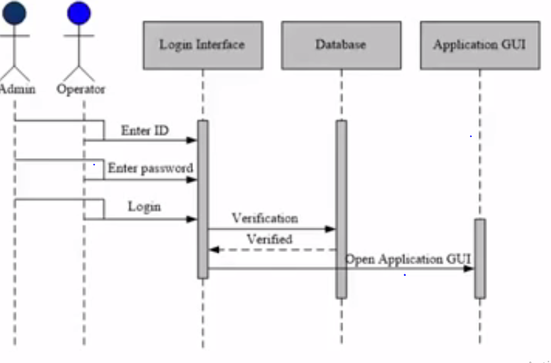
- Add/Register/Manage Customers:
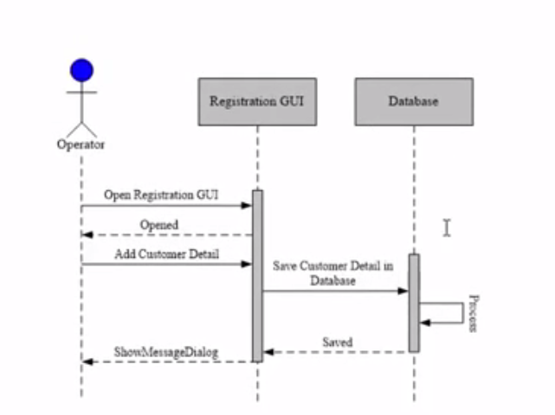
- Add Cake Detail:

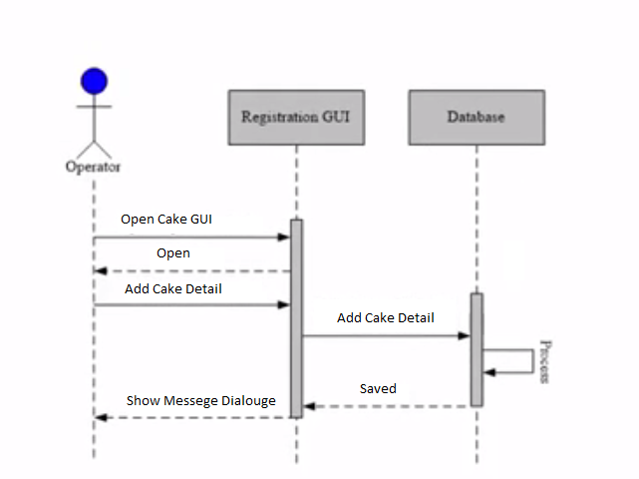
- Daily Cake Delivery Detail:
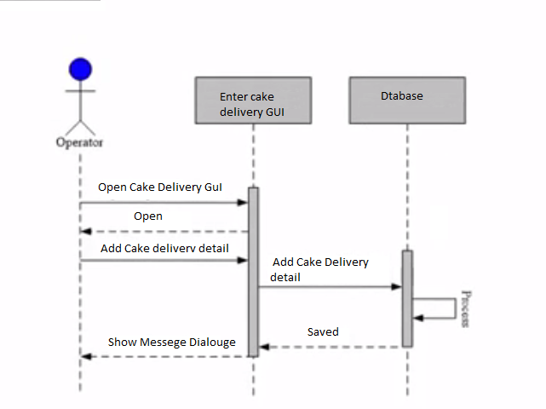
- Door Step Facility:
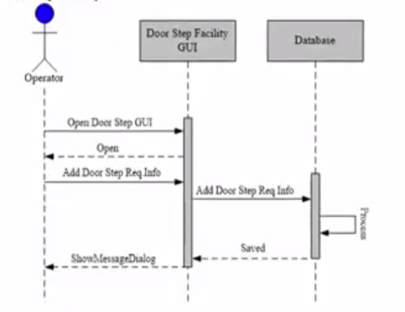
- Feedback Detail
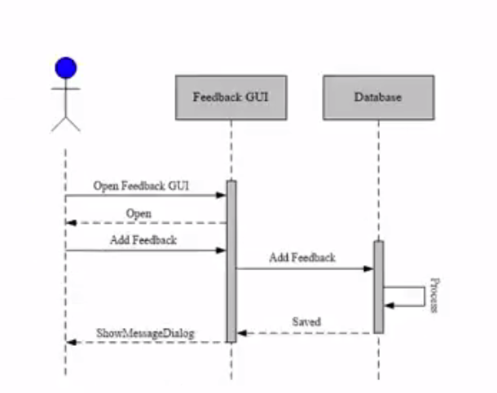
- Give Incentive Promotion:

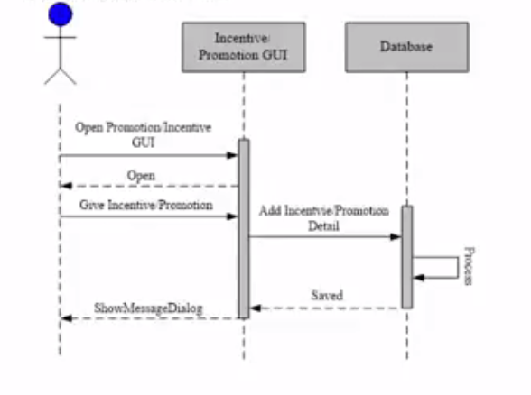
f. Bill/Print Performa:
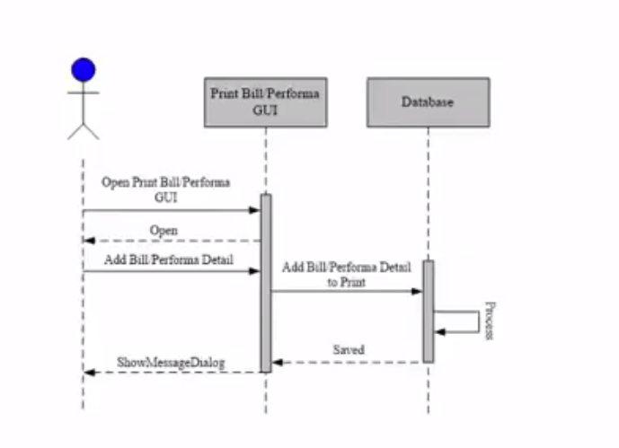
- Manage customers:
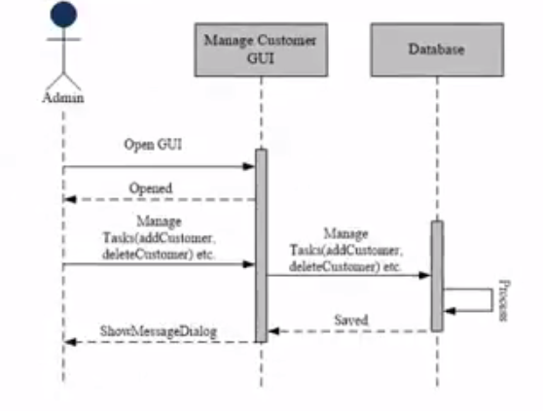
- Add/Manage Operator/User:
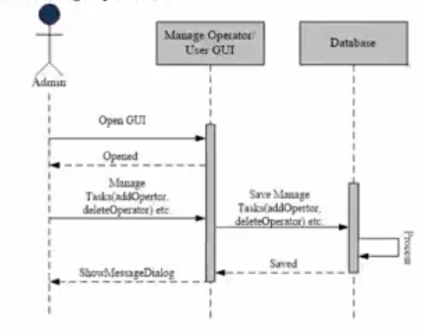
- Manage inventory Record/Details:
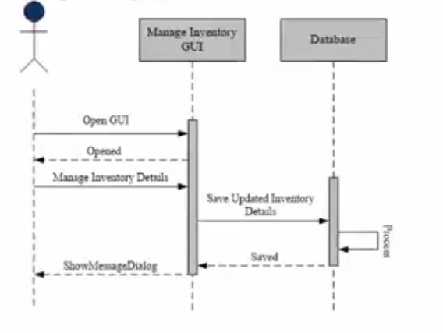
- Feedback By Customer:
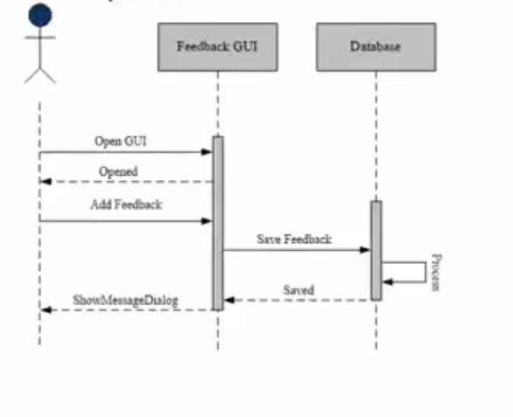

- Architecture Design Diagram

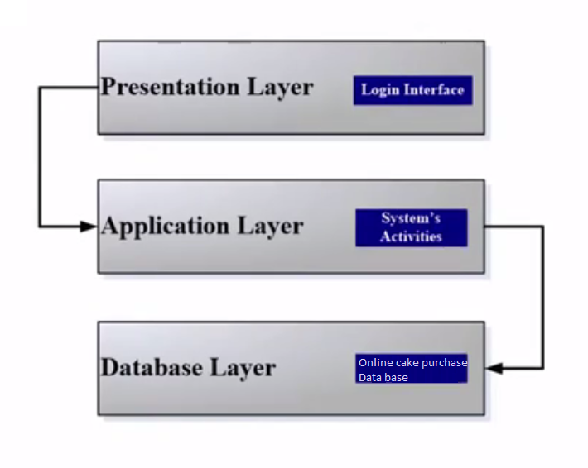
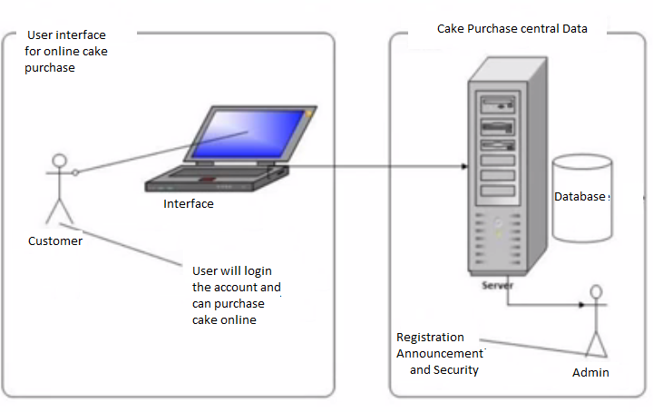
- Class Diagram

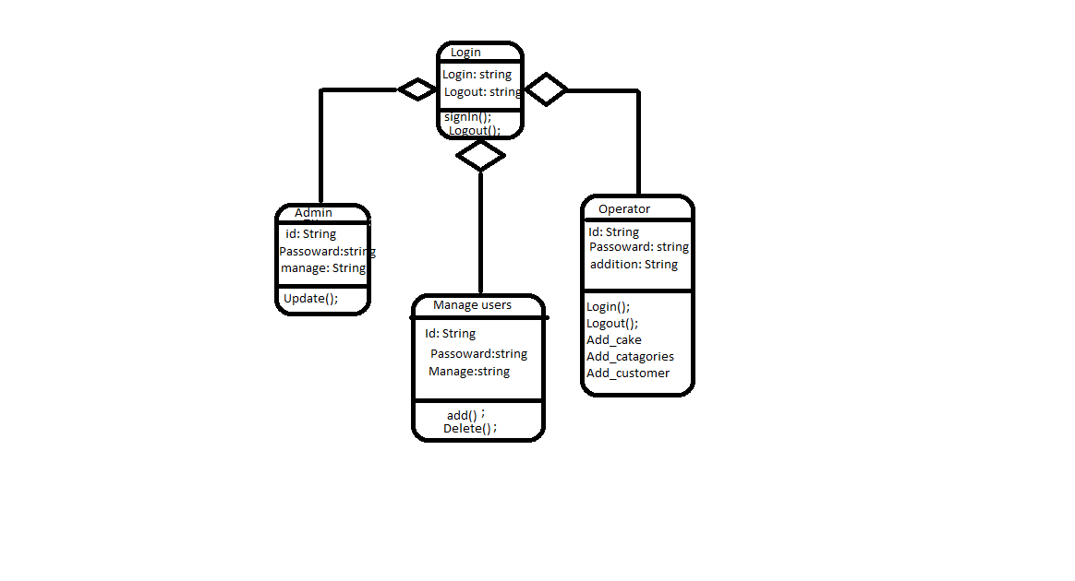

- Database Design
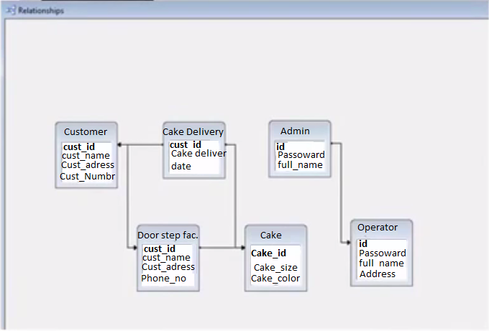

- Interface Design

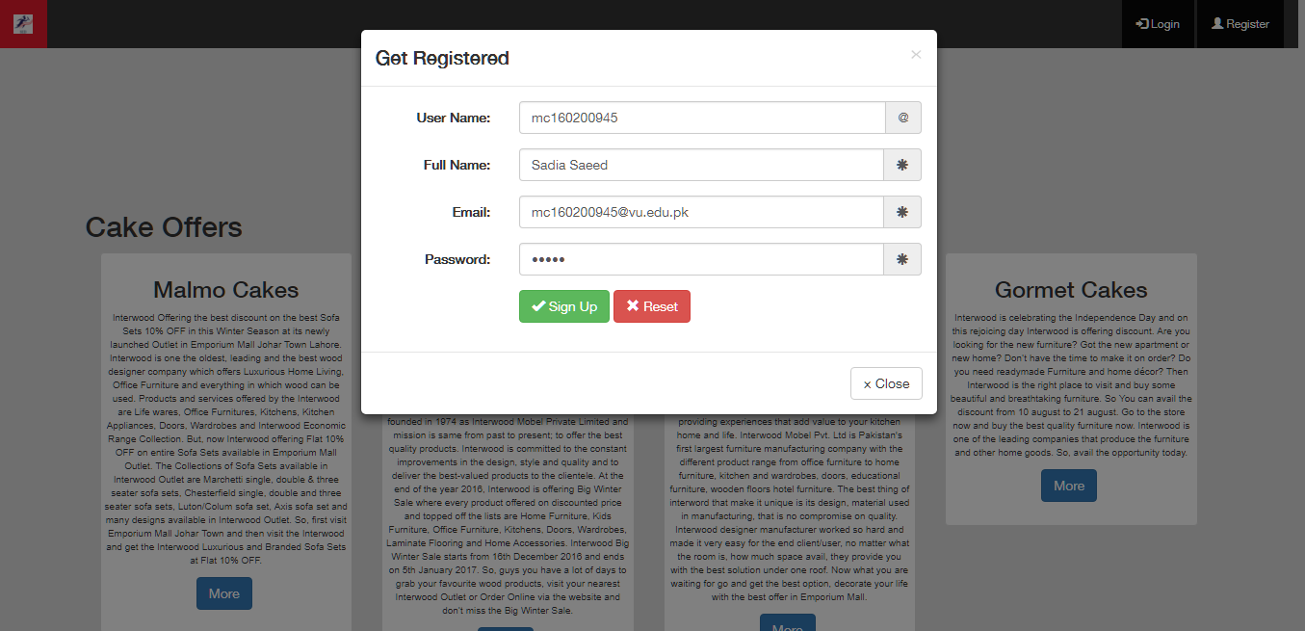
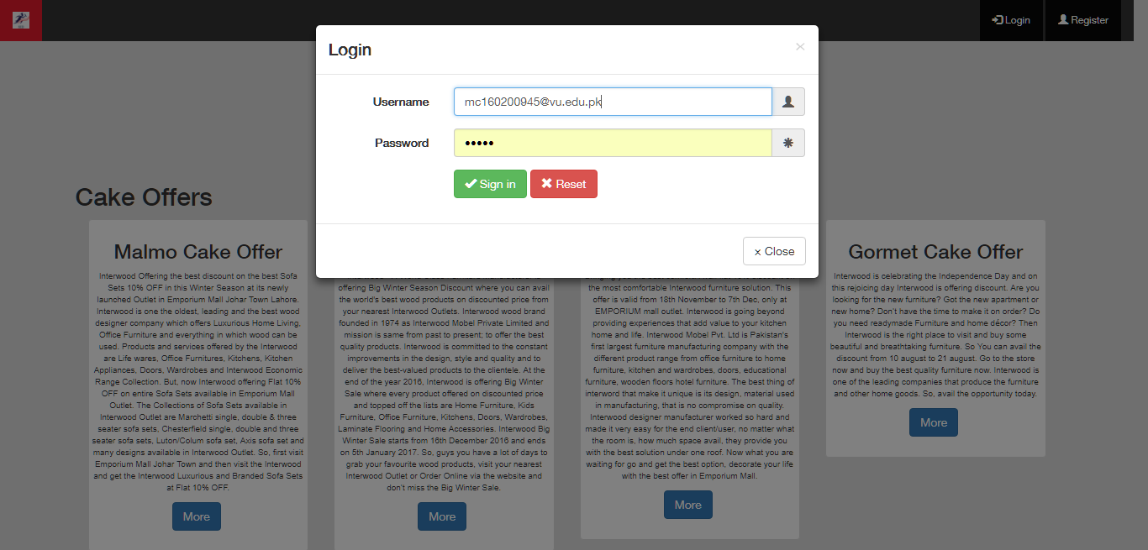

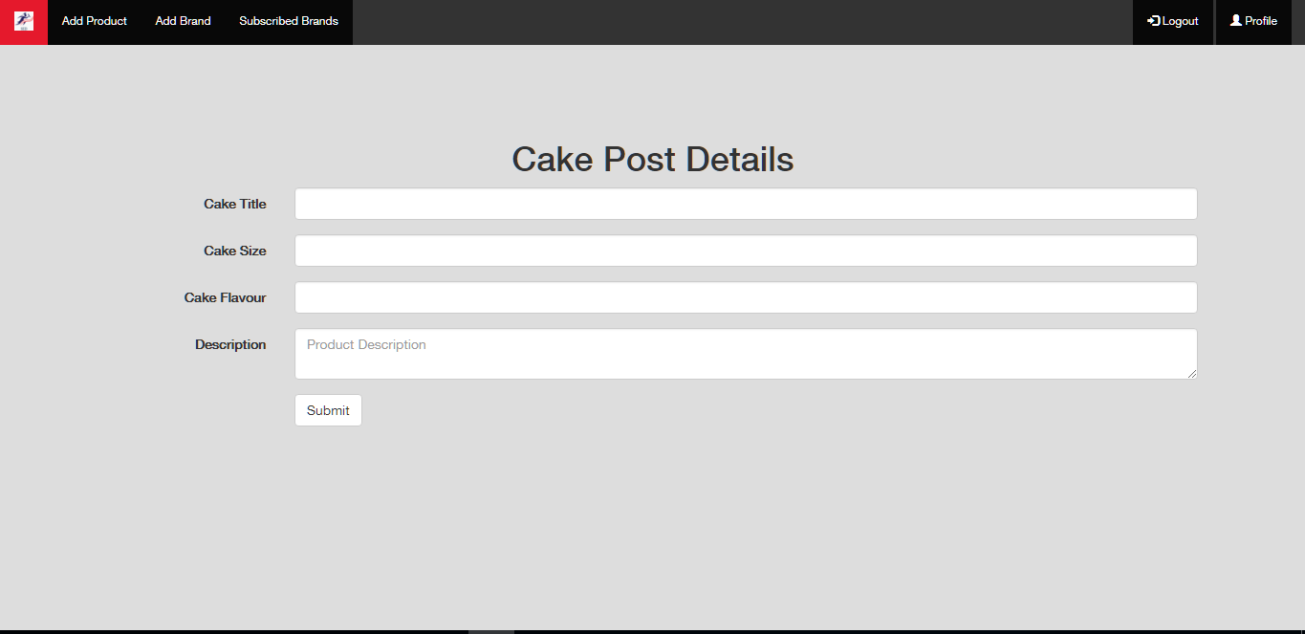
- Test Cases

Sr no. | Test case |  | Test Technique |  | Pass/Fail |  |  | Remarks
1 | Login into system |  | Require field  validation control |  | Pass |  |  | _
2 | Add/Register/Manage Customers |  | Require field  validation control |  | Pass |  |  | _
3 | Add cake detail |  | Require field  validation control |  | Pass |  |  | _
4 | Daily cake delivery detail |  | Require field  validation control |  | Pass |  |  | _
5 | Door Step Facility |  | Require field  validation control |  | Pass |  |  | _
6 | Feedback Detail |  | Require field  validation control |  | Pass |  |  | _
7 | Give Incentive promotion |  | Require field  validation control |  | Pass |  |  | _
9 | Bill/Print Performa |  | Require field  validation control |  | Pass |  |  | _
10 | Manage Customers |  | Require field  validation control |  | Pass |  | _
11 | Add/manage operator user |  | Require field  validation control |  | Pass |  | _
12 | Manage inventory record/ Detail |  | Require field  validation control |  | Pass |  | _
13 | Feedback By customers | Require field  validation control |  | Pass |  | _

